Project Name | RK-HEALTH
Date | 3 July 2026
Team ID

Phase 2: Data Flow Diagrams & User Stories

1. Level 0 Data Flow Diagram (Context Diagram)
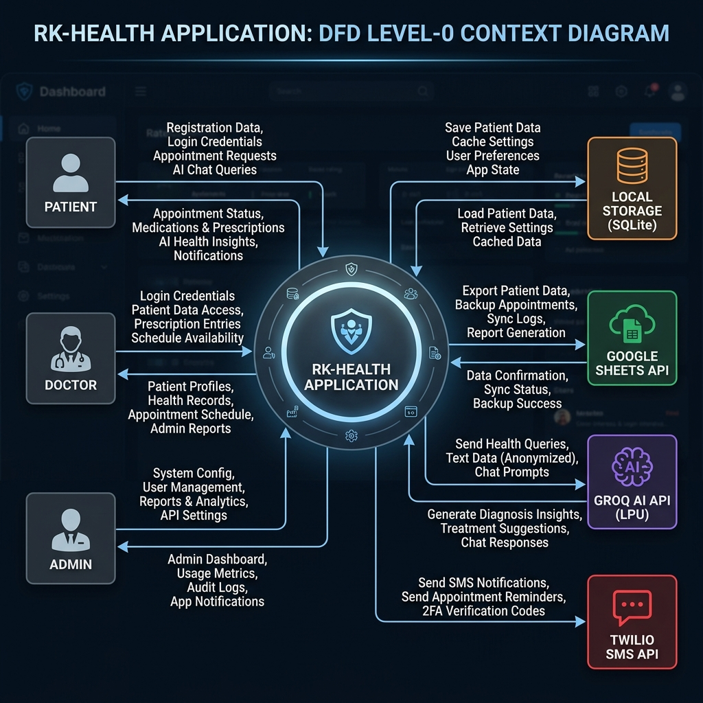
Figure 1: Context Level-0 Data Flow Diagram of RK-HEALTH System
2. Data Stores and Flows Description
• External Entities: Patient (primary user), Doctor (reviews appointments), Admin (manages doctors & user roles).
• Main Process: RK-HEALTH System acts as central processing gateway.
• Local Storage (D1): Client-side offline-first storage for appointments and meds.
• Google Sheets (D3): Cloud database synced via AppScript proxy.
• Groq AI API (D2) & Twilio API (D4): External cloud gateways for LLaMA 3.3 symptom processing and SMS text reminders.
3. Detailed User Stories table
User Role | Feature Area | Story ID | Story Narrative | Acceptance Criteria | Priority | Sprint
Patient | Auth | US-01 | As a patient, I can log in securely | Correct dashboard rendered | High | Sprint-1
Patient | Dashboard | US-02 | As a patient, I want to see my medication compliance logs | Compliance chart updates dynamically | High | Sprint-1
Patient | Appointments | US-03 | As a patient, I can schedule appointment slots with doctors | AI summaries generated and logged | High | Sprint-2
Patient | Appointments | US-04 | As a patient, I can export appointments to Google Calendar | One-click calendar setup link generated | Medium | Sprint-2
Patient | Medications | US-05 | As a patient, I want to log pill dose timing and schedules | Medication checklist populated | High | Sprint-2
Patient | AI Chatbot | US-06 | As a patient, I want the bot to guide me through symptoms | Bot queries details and maps specialist | High | Sprint-3
Patient | Reports | US-07 | As a patient, I want to print my health summary | Print-ready consolidated layout generated | Medium | Sprint-3
Doctor | Dashboard | US-08 | As a doctor, I want to see my patients schedule | Lists doctor-specific appointments | High | Sprint-4
Admin | Doctors CRUD | US-09 | As an admin, I can add/remove doctors in directory | Drop-downs reflect active directory | High | Sprint-4
Admin | User Roles | US-10 | As an admin, I want to promote users to doctor accounts | Role permissions updated in db | High | Sprint-4

